Problem Related to Water Reservoir
Time Calculation

11/18/2015
Submitted For: Shuvo Khadem
Submitted By: Sheikh Muhammad Muhtashim Abid

Table of Contents
Theory 2
Orifice Discharge Coefficient 3
Problem of the Equation 3
Problem Related to the Equation 4
Reference 5

Theory
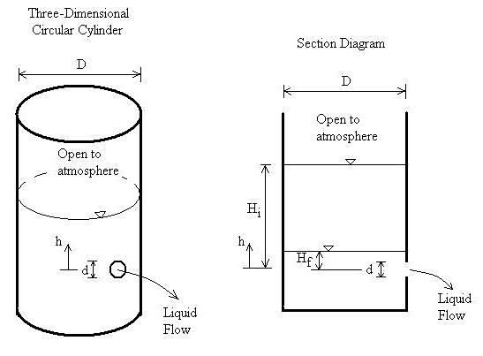
If a tank and orifice are both at atmospheric pressure and the liquid is above the top of the orifice, the discharge (flow rate) out of the orifice is,
Q = aC√2gh
The above equation is valid if both the tank and orifice are at the same pressure, even if the pressure is not atmospheric.
For a tank with a constant cross-sectional geometry A in the plan view (i.e. as you look down on it), substitute:
Q = -A (dh/dt)
Integrate h from H_{i} to H_{f} and integrate t from 0 to t, then solve for time t, which is the time required for the liquid to fall from H_{i} to H_{f},
t = (A/aC) (√H_{i} - √H_{f}) {√(2/g)}
Here, a = Orifice cross-sectional area (m²)
A = Tank cross-sectional area (m²)
C = Orifice discharge coefficient 0 < C < 1.0. C depends on the orifice geometry and in some cases the type of liquid
g = Acceleration due to gravity, 9.8066 (m/s²)
h = Vertical distance from centerline of orifice to liquid surface (m)
H_{f} = Final vertical distance from centerline of orifice to liquid surface (m)
H_{i} = Initial vertical distance from centerline of orifice to liquid surface (m)
Q = Discharge (flow rate) at any depth (m³/s)
t = Time for liquid in tank to change from a depth of H_{i} to a depth of H_{f} (sec.)

Orifice Discharge Coefficient
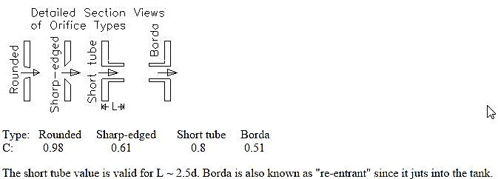

Problem of the Equation
- If h drops below the top of the orifice (for instance if H_{f} is below the top of the orifice), the method will give shorter emptying times than in reality. The program assumes that liquid is flowing out through the entire orifice area. However, when the liquid drops below the top of the orifice, flow is out of an area less than the full orifice area.
- The tank and orifice discharge are assumed to be at the same pressure.
- The tank is assumed to be of sufficiently larger area than the orifice so that friction effects from the tank wall are negligible.
(1. LMNO Engineering, Research, and Software, Ltd, 2015)

Problem Related to the Equation
10 m
20 m
15 m
10 cm φ
1 m

Calculate the required time to empty the overall water tank.
a = (πd² / 4) = 7.853981634 x 10⁻³ m²
A = 20 x 10 = 200 m²
g = 9.8066 m²
C = short tube = L – 2.5d = 1 – 2.5 (10/100) = 0.75
h = 15 – (5/100) = 14.95 = H_{i}
H_{f} = 0 [We want the tank fully emptied]
So, t = (A/aC) (√Hi - √Hf) {√(2/g)}
= 44464.81378 sec.
= 12.352 hours.

Reference
1. LMNO Engineering, Research, and Software, Ltd. (2015, August 25). Time to Empty or Drain a Tank, Pond, Reservoir Containing Water or other Liquid. Retrieved November 18, 2015, from lmnoeng.com: http://www.lmnoeng.com/Tank/TankTime.php

